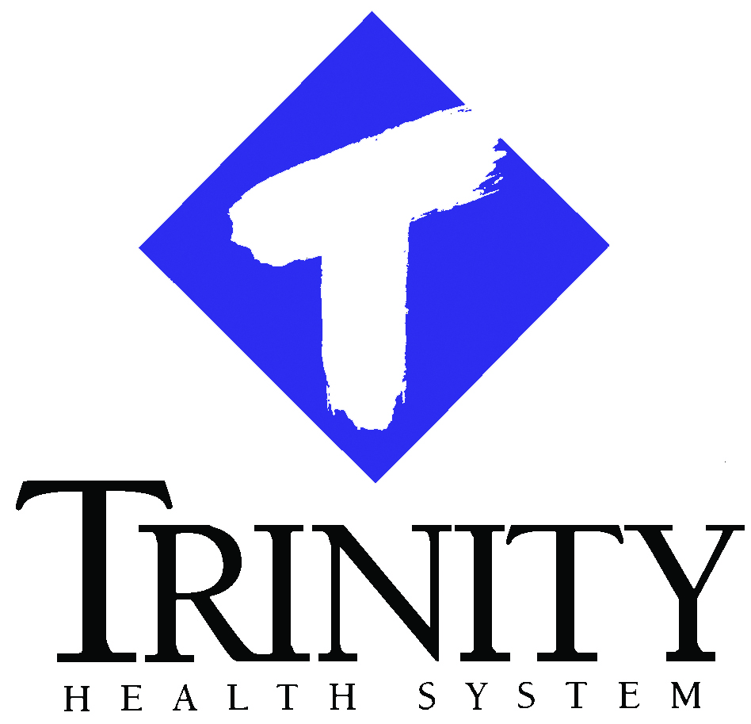

**Community Health Needs Assessment**

**Trinity Health System**

**June 2016**

**COMMUNITY HEALTH NEEDS ASSESSMENT**

**TRINITY HEALTH SYSTEM**

**Questions may be directed to:**

**Fred Brower**

**President and CEO**

**Trinity Health System**

[**fbrower@trinityhealth.com**](mailto:fbrower@trinityhealth.com)

**Keith Murdock**

**Director, Community Relations**

**Trinity Health System**

[**kmurdock@trinityhealth.com**](mailto:kmurdock@trinityhealth.com)

**June 2016**

Contents

Trinity Health Mission Statement 4

Acknowledgments 5

Introduction 6

Community Health Needs Assessment 6

Requirement 6

Methodology 7

Defining the Community Served 7

Assessment of Health Needs – Methodology and Data Sources 7

Qualitative Assessment of Health Needs 7

Quantitative Assessment of Health Needs 9

Ranking System 10

Data Quality 11

Calculating Scores and Ranks 11

Information Gaps 11

Prioritizing Community Health Needs 11

Key Qualitative Findings 13

Health Needs to be Addressed by Trinity Health 16

Mental Health/Substance Abuse 16

Wellness/Prevention 16

Access to Primary Care 17

Summary 17

Key Quantitative Findings 17

County Profile 17

Health Outcomes 20

Health Behaviors 21

Clinical Care 21

Social Health and Mortality 21

Appendix A: Community Resources to Address Significant Health Needs 24

Appendix B: Implementation Strategies based on CHNA conducted in 2013 29

# Trinity Health Mission Statement

**OUR MISSION**

The Mission of Catholic Health Initiatives is to nurture the healing ministry of the Church, supported by education and research. Fidelity to the Gospel urges us to emphasize human dignity and social justice as we create healthier communities.

**OUR VISION**

Our Vision is to live up to our name as One CHI:

* **Catholic:** Living our Mission and Core Values
* **Health:** Improving the health of the people and communities we serve
* **Initiatives:** Pioneering models and systems of care to enhance care delivery

**OUR CORE VALUES**

* **Reverence:** Profound respect and awe for all of creation, the foundation that shapes spirituality, our relationships with others and our journey to God
* **Integrity:** Moral wholeness, soundness, fidelity, trust, truthfulness in all we do
* **Compassion:** Solidarity with one another, capacity to enter into another’s joy and sorrow
* **Excellence:** Preeminent performance, becoming the benchmark, putting forth our personal and professional best

# Acknowledgments

Trinity Health System would like to thank the following individuals and organizations for their willingness to assist in our process of assessing the community that Trinity Health serves.

1. ALIVE Shelter
2. American Red Cross
3. BHS Metro Planning
4. City Rescue Mission
5. Department of Health, City of Steubenville
6. Eastern Gateway Community College
7. Family and Community Services
8. Franciscan University
9. IBEW Local Union 246
10. Jefferson Behavioral Health System
11. Jefferson County 4th St. Health Center
12. Jefferson County Board of Developmental Disabilities
13. Jefferson County Chamber of Commerce
14. Jefferson County Prevention and Recovery Board
15. Jefferson Metro Housing Authority
16. Prime Time Office on Aging
17. Steubenville City Schools
18. Therapeutic Connections Charitable Pharmacy
19. United Way
20. Urban Mission
21. Village of Wintersville
22. Women’s Health Center

# Introduction

The 2016 Trinity Health System Community Health Needs Assessment (CHNA) is a comprehensive evaluation of the health needs of the community that Trinity Health serves. The system was formed in 1996 through a creative and collaborative partnership with Tri-State Services and Sylvania Franciscan Health, and later acquired by Catholic Health Initiatives in 2014. The system consists of Trinity Medical Center West and Trinity Medical Center East in Steubenville with a combined capacity of 471 beds, and Trinity Hospital Twin City (25 beds) in Dennison, providing the most complete health care option in eastern Ohio. For 20 years, Trinity Health has continued to enhance the qualities and services for the residents of the tri-state area to improve their access to excellent, person-centered care.

# Community Health Needs Assessment

## Requirement

As a result of the Patient Protection and Affordable Care Act (PPACA) and as part of the IRS Form 990 Schedule H, all tax-exempt (501(c)(3)) hospitals, beginning in fiscal year 2013, are required to assess the health needs of their community (through a CHNA), prioritize the significant health needs, and develop implementation plans for those prioritized health needs the organization has chosen to address. This assessment will be done once every three years. A CHNA is a written document developed for a hospital that includes descriptions of the following:

* The community served and how the community was determined
* The process and methods used to conduct the assessment including sources and dates of the data and other information as well as the analytical methods applied to identify significant community health needs
* How the organization took into account input from persons representing the broad interests of the community served by the hospital, including a description of when and how the hospital consulted with these persons or the organizations they represent
* The prioritized community health needs identified through the CHNA as well as a description of the process and criteria used in prioritizing the identified significant needs
* The existing health care facilities and other resources within the community available to meet the significant community health needs

The CHNA requirement also stipulates that hospitals must adopt an Implementation Strategy to meet the significant community health needs identified through the assessment. An Implementation Strategy is a written plan that addresses each of the significant community health needs identified through the CHNA and is a separate but related document to the CHNA report.

The written Implementation Strategy must include the following:

* List of the prioritized needs the hospital plans to address and the rationale for not addressing other significant health needs identified
* Actions the hospital intends to take to address the chosen health needs
* The anticipated impact of these actions and the plan to evaluate such impact (e.g. identify data sources that will be used to track the plan’s impact)
* Identify programs and resources the hospital plans to commit to address the health needs
* Describe any planned collaboration between the hospital and other facilities or organizations in addressing the health needs

A CHNA is considered conducted in the taxable year that the written report of its findings, as described above, is approved by the hospital governing body and made widely available to the public. The Implementation Plan is considered implemented on the date it is approved by the governing body. Conducting the CHNA and approval of the Implementation Strategy must occur in the same fiscal year.

## Methodology

Trinity Health has developed a Community Health Needs Assessment (CHNA) for the following facilities:

* Trinity Medical Center East
* Trinity Medical Center West

## Defining the Community Served

Trinity Health approached the CHNA process as a collaborative effort between these two hospitals with both hospitals adopting a single community served. In order to define the community served for the purposes of this assessment, Trinity Health evaluated the total population, Trinity inpatient discharges, Ohio/West Virginia/Pennsylvania inpatient discharges, and Medicare market share for the counties surrounding Trinity Health. Trinity Health is dependent on Jefferson County for 71% of its inpatient discharges. A review of Medicare data also indicates that the majority of Medicare patients (60% market share) who reside in Jefferson County, seek services at Trinity Health. The surrounding counties are each served by other providers in the region. Therefore, for the purposes of the CHNA, the Trinity Health community served is defined as Jefferson County, Ohio.

# Assessment of Health Needs – Methodology and Data Sources

To assess health needs of the Trinity Health community, a quantitative and qualitative approach was used. In addition to collecting data, including data collected in 2013 and 2016, from a number of public sources, interviews and focus groups were conducted with individuals representing community leaders/groups, public organizations, patients, providers, and Trinity Health representatives.

Based upon the assessment of the actions taken during the 2013 - 2015 period, the system concluded that the 2013 data and information sources were still relevant to the needs assessment in 2016. Throughout this report, references to both 2013 and 2016 information will be found.

## Qualitative Assessment of Health Needs

Trinity Health collaborated with other local organizations and providers to take into account the input of persons representing the broad interests of the community. Representatives included a diverse mix of individuals from the City of Steubenville Health Department, Jefferson County Health Department and representative members of other community agencies including the area United Way, public senior housing, the YMCA and Prime Time Services. Ten one-to-one interviews were conducted as well as focus groups totaling forty participants.

All fifty Individuals were grouped into the following categories to ensure broad participation: community leaders/groups, public health and other healthcare organizations, other providers (including physicians), and Trinity Health representatives.

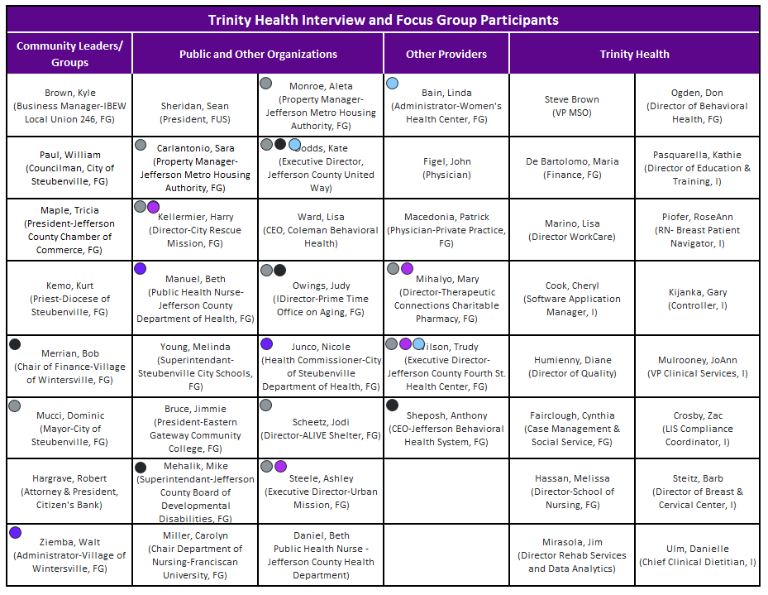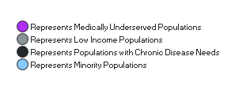

The interview questionnaire was designed to understand how participants feel about the general health status of the community and the various drivers contributing to health issues. Focus groups were designed to familiarize community members with the CHNA process and gain a better understanding of the community’s perspective of priority health needs. They were formatted for individual as well as small group feedback and also helped identify other community organizations already addressing health needs in the community.

## Quantitative Assessment of Health Needs

In addition to the qualitative feedback, quantitative health indicators were collected and analyzed to assess community health needs. Sixty-nine indicators were evaluated for Jefferson County during the 2013 needs assessment. The categories and indicators included the following:

|  |  |  |
| --- | --- | --- |
| **Population**   * High School Graduation Rate * Students Graduating from High School * Some College * Births to Unmarried Women * Children in Poverty * Children in Single-Parent Households * Children Receiving SNAP Benefits * Food Insecure Children * Estimated Number of Persons Living Below the Poverty Line * Unemployment Rate * Percent Rural * Violent Crime Rate * Homicides   **Injury & Death**   * Heart Disease Death Rate * Overall Cancer Death Rate * Chronic Lower Respiratory Disease (CLRD) Death Rate * Stroke Death Rate * Unintentional Injury Death Rate * Alzheimer's Disease Death Rate * Premature Death * Motor Vehicle Crash Mortality Rate   **Mental Health**   * Population to Mental Health Provider Ratio * Suicide Rate * Poor Mental Health Days * Inadequate Social Support | **Health Outcomes**   * Poor or Fair Health * Average Number of Poor Physical Unhealthy Days in Past Month * Cancer (all causes) Incidence * Breast Cancer * Colon Cancer * Lung Cancer * Percent Diabetic * Adults Reporting Diagnosed with Hypertension * Infant Mortality * Mothers Not Receiving First Trimester Prenatal Care * Low Birth Weight * Preterm Births   **Health Behaviors**   * Adult Obesity * Childhood Obesity * Physical Inactivity * No Exercise * Percent Consuming Less Than 5 Fruits/ Vegetables Per Day * Adult Smoking * Adults Engaging in Binge Drinking During the Past 30 Days * Birth Rate to Teens Age 15-17 * Teen Birth Rate * HIV Prevalence * Sexually Transmitted Infection Incident Rate | **Access to Care**   * Percent Uninsured * Uninsured Children (<17) * Could Not See a Doctor Due to Cost * Primary Care Physicians per 100,000 population * Population to Primary Care Physician Ratio * Dentists per 100,000 Population * Population to Dentist Ratio * Third Graders with Untreated Tooth Decay * Preventable Hospital Stays   **Prevention**   * Diabetic Screening * Mammography Screening * Pap Smear * Flu Vaccine 65+ * Ever had Pneumonia Vaccine Adults 65 Years and Older   **Environment**   * Number of Recreational & Fitness Facilities * % Access to Parks * Fast Food Restaurants * Limited Access to Healthy Foods * Students Eligible for Free Lunch * Daily Particulate Matter Days Drinking Water Safety |

This data was supplied by the County Health Rankings & Roadmaps Database data from 2015. For each health indicator, a comparison was made between the county level data and benchmarks. Benchmarks were based on available data and included the United States and the State of Ohio. Health needs were identified where the county indicator did not meet the State of Ohio comparative benchmark.

### Ranking System

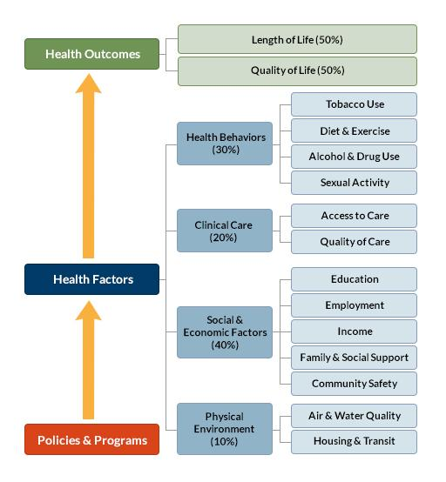

​

The *County Health Rankings* are based on counties and county equivalents (ranked places). Any entity that has its own Federal Information Processing Standard (FIPS) county code is included in the *Rankings*. Only counties and county equivalents within a state are ranked. The major goal of the *Rankings* is to raise awareness about the many factors that influence health and that health varies from place to place, not to produce a list of the healthiest 10 or 20 counties in the nation and only focus on that.

Counties in each of the 50 states are ranked according to summaries of a variety of health measures. Those having high ranks, e.g. 1 or 2, are considered to be the “healthiest.” Counties are ranked relative to the health of other counties in the same state. We calculate and rank eight summary composite scores:

* Outcomes Health Outcomes
* Health Outcomes – Length of life
* Health Outcomes – Quality of life
* Overall Health Factors
* Health Factors – Health behaviors
* Health Factors – Clinical care
* Health Factors – Social and economic factors
* Health Factors – Physical environment

The *County Health Rankings* team synthesizes health information from a variety of national data sources to create the Rankings. Most of the data we use are public data available at no charge. Measures based on vital statistics, sexually transmitted infections, and Behavioral Risk Factor Surveillance System (BRFSS) survey data were calculated by staff at the National Center for Health Statistics and other units of the Centers for Disease Control and Prevention (CDC). Measures of health care quality were calculated by staff at The Dartmouth Institute.

### Data Quality

The *County Health Rankings* team draws upon the most reliable and valid measures available to compile the *Rankings*. Where possible, the margin of errors (95% confidence intervals) are provided for various measure values. In many cases, the values of specific measures in different counties are not statistically different from one another; however, when combined using the *Rankings* model, those various measures produce the different rankings.

### Calculating Scores and Ranks

The *County Health Rankings* are compiled from many different types of data. To calculate the ranks, each of the measures is first standardized. The ranks are then calculated based on weighted sums of the standardized measures within each state. The county with the lowest score (best health) gets a rank of #1 for that state and the county with the highest score (worst health) is assigned a rank corresponding to the number of places that were rank in that state.

The *Rankings* are based on a model of population health that emphasizes the many factors that, if improved, can help make communities healthier places to live, learn, work and play. Building on the work of [America's Health Rankings](http://www.americashealthrankings.org/), the [University of Wisconsin Population Health Institute](http://uwphi.pophealth.wisc.edu/) has used this model to [rank the health of Wisconsin’s counties](http://uwphi.pophealth.wisc.edu/programs/match/wchr/index.htm) every year since 2003.

# Information Gaps

The majority of health indicators are only available at the county level. In evaluating data for entire counties versus ZIP code level data, it is difficult to understand the health needs for specific population pockets within a county. It is also a challenge to tailor programs to address community health needs as placement and access to those programs in one part of the county may or may not actually impact the population who truly need the service.

# Prioritizing Community Health Needs

To prioritize the health needs identified, a prioritization session was facilitated with Trinity Health representatives and one external representative. Participants included:

* Fred Brower, President & CEO
* Steve Brown, VP, Management Services Organization
* Gray Goncz, D.O, VP, Medical Affairs
* JoAnn Mulrooney, VP, COO
* Lew Musso, VP, Human Resources
* Dave Werkin, VP, Finance & CFO
* Keith Murdock, Foundation/Marketing, Public Relations
* Kathie Pasquarella, Director, Education/Training
* Maria DiBartolomeo, Manager, Decision Support/Budgeting
* Michelle Wilson, YMCA Executive Director (external)

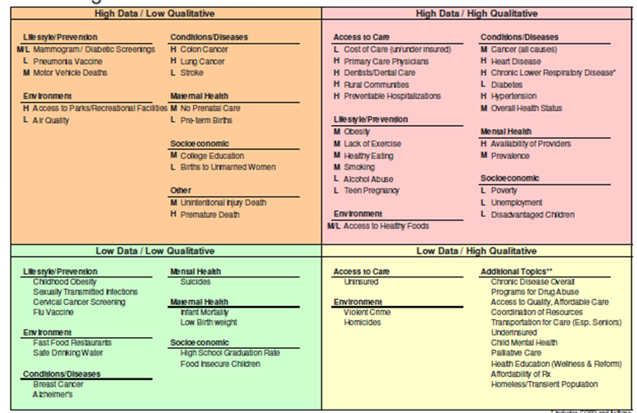Using qualitative feedback from the interviews and focus groups, as well as the health indicator data, the issues currently impacting the community were consolidated and assembled in the following matrix to assist in identifying the significant health needs.

* Includes COPD and Asthma **No indictor data for these measures

The upper right quadrant of the matrix is where the qualitative data (interview and focus group feedback) and quantitative data (health indicators) converge. The upper right quadrant contains, for the sake of this analysis, the most significant community health needs identified. After reviewing the community needs in the matrix above, participants agreed to focus prioritization efforts on the upper right quadrant of the matrix.

The CHNA prioritization process utilized a modified version of a method developed by Hanlon and his colleagues (see Hanlon & Pickett, 1990). First, the group selected the criteria by which to prioritize the health needs. The participants reviewed a list of nine criteria commonly used in needs prioritization. Those criteria included:

1. **Magnitude -** How many persons does the problem affect, either actually or potentially?
2. **Consequences -** What degree of disability or premature death occurs because of the problem? What are the potential burdens to the community, such as economic or social burdens?
3. **Feasibility -** Is the problem amenable to interventions? What technology, knowledge, or resources are necessary to effect a change? Is the problem preventable?
4. **Vulnerable Populations -** Is there a high need among vulnerable populations?
5. **Root Cause -** Is the issue a root cause of other problems? Thereby possibly affecting multiple issues.
6. **Hospital Capacity -** Does the hospital have the capacity to act on the issue, including any economic, social, cultural, or political consideration?
7. **Hospital Strength -** Extent to which initiatives that address the health issue can build on hospital existing strengths and resources?
8. **Expertise -** Availability of local expertise regarding the health need
9. **Quick Success -** The probability of quick success. Is the problem “low-hanging fruit?”

Participants were given the opportunity to remove items or add additional items to the list of criteria. After a discussion the group decided to add the criteria of **Current Strategic Alignment –** does the organization currently have initiatives that could encompass the health need? Participants were then asked to select the top 3-5 prioritization criteria.

Using a multi-voting process, the criteria selected included **magnitude, feasibility, hospital strength, current strategic alignment,** and **root cause**. After choosing the criteria, participants worked in small groups and rated each significant community health need using the criteria selected. This rating process determined an overall score for each significant health need. Health needs that scored the highest against the selected criteria served as the starting point for the health needs to be addressed.

# Key Qualitative Findings

The following is a recording of the questions posed and their responses:

1. How has the local community that the hospital served changed in the past two years?
   1. Aging population
   2. Drug addiction
   3. Economy
   4. Increase in the number of underserved population
   5. Obesity
   6. Diabetes
   7. Mental health issues
   8. Cancer diagnoses
   9. Cardiac-related issues
   10. Hepatitis C
2. What grade would you give to the current health status of the community?
   1. “C” – 5
   2. “D” – 45

Focus group participants were asked to “grade” the health of the community based on an A-F scale, and provide feedback in terms of that grade. For the community served by Trinity Health, the average grade for the health of the community was a “C.” Much of this was attributed to the downturn in unemployment, the aging population, chronic conditions/diseases, prevention/lifestyle issues and the high rates of substance abuse, crime and violence in the area. Some positive feedback included the community’s overall strength and resilience and the number of health resources available. Barriers to good health care in this community include lack of insurance coverage, lack of health education, coordination of resources, access to health services (wait times), and financial resources.

1. In regard to the community the hospital serves, what do you think are the top health needs?
   1. Drug abuse/treatment
   2. Cancer treatment
   3. Cardiac care
   4. More physicians (especially PCPs)
   5. Preventative health
   6. Mental health services
   7. Programs for the aging population
2. What is the largest unmet health need?
   1. Mental health/Substance abuse
   2. Wellness/Prevention
   3. Access to primary care
3. What healthcare services are missing in the community?
   1. Halfway houses for addicted individuals
   2. Homeless shelters
4. What is the number one barrier to good health in the community?
   1. Finances
5. What concerns you most about the health of the community the hospital serves?
   1. Increase in substance abuse
   2. Aging population including physicians
6. What are the leading social factors that impact the health of the community?
   1. Unemployment
   2. Working poor
7. As we look at health indicators, which do you think would be the best measures of the health of the community?
   1. Number of overdoses
   2. Ratio of physicians to population
   3. Average weight and blood pressure of residents
   4. Number of diabetics
   5. Cancer diagnoses
   6. Cardiac events
8. Regarding the community the hospital serves, are there any vulnerable groups/populations to which we should pay special attention?
   1. Youth
9. Are there any community-based organizations already addressing community health issues?
   1. City Health Department
   2. County Health Department
   3. Ohio Valley Health Center (free clinic)
   4. Family Resource Center
   5. Family Services
   6. Urban Mission
   7. City Rescue Mission
   8. Prime Time Senior Center
10. In terms of specific actions/programs, what do you think could be done to address the health needs we have discussed?
    1. Halfway house for addicted individuals
    2. More recreational areas
    3. Health screenings
    4. Affordable health insurance
    5. Physician recruitment

Focus group participants were asked to identify community resources that could help address the health issues in the community. Some of the resources are noted in the table below. **Appendix A** includes a more comprehensive list of existing community resources available to address the significant health needs of the community.

## Health Needs to be Addressed by Trinity Health

The participants reached a consensus regarding the three most pressing issues that Trinity Health needs to address though an Implementation Strategy:

* Mental Health/Substance Abuse
* Wellness/Prevention
* Access to Primary Care

By addressing the above needs through the Implementation Strategy, Trinity Health will also aim to impact the overall health status of the community which also scored high in the prioritization process.

### Mental Health/Substance Abuse

Every participant was in agreement that opioid addiction was the most serious problem in the local community. Overdoses have been steadily increasing in the past few years and have reached an alarming rate. The use of overdose-reversing medications (Narcan) have reduced the death rate, but the number of overdoses continues to increase. Some participants stated that the use of these medications was a “free pass” for the drug abusers and some recounted stories of siblings and children being taught how and when to inject these medications in the event of an overdose by a sibling, parent, family member or friend. They also stated that many of the opioid addicts began to use heroin after the supply of oral opioids was reduced by law enforcement activity in the medical community. They were also in agreement that following an overdose and treatment at a healthcare facility, many of the drug abusers returned to their previous habits and overdosed again. The group was also concerned about the increase in the crime rate by these individuals to support their drug abuse. When asked for the root cause of drug abuse in the local community, among the several reasons provided, mental Health issues and socio-economic conditions were the most common responses. Given the resources available, it was decided that a community effort involving all of the Mental Health and Substance Abuse agencies was needed. Don Ogden, THS Director of Behavioral Medicine will take the lead in this effort.

### Wellness/Prevention

The participants realized that the partnership between Trinity Health System and the YMCA has been a positive step and that other wellness-related facilities have also begun to offer services, but only a small percentage of the population was taking advantage of these services. The participants stated that a more concerted effort toward personal commitment to maintaining health was necessary. Most agreed that the local population does not accept personal responsibility for their own health. Mental health issues, socio-economic conditions and apathy were all mentioned as top reasons for this attitude. Youth activities and programs for seniors were recommended as possible solutions. Reducing the number of cancer diagnoses, cardiac-related emergencies, diabetes diagnoses and pulmonary issues would be effected through such an effort. Smoking cessation, exercise and nutrition should be stressed in all segments of the population. JoAnn Mulrooney, THS VP & COO and Keith Murdock, THS Director of Community Relations will lead this effort.

### Access to Primary Care

All participants agreed that more primary care physicians were necessary in the community. The aging of the local medical staff also posed a concern to the group. Scheduling appointments for new patients and existing patients was becoming more difficult. Participants stated that without a stable base of physicians presently and into the future, the health needs of the local population would be in jeopardy. They also recommended that Urgent Care facilities such as ExpressCare and the ExpressClinics be expanded to help alleviate the shortage. Many of the participants shared personal experiences regarding the difficulty to obtain prompt and effective treatment through their personal physician. New patients seeking appointments were waiting as long as six months for their first appointment. Several stated that they knew of patients whose physicians had left Trinity Health System, were having similar problems transferring to new physicians on Trinity’s medical staff. A referral system was recommended to make this process more convenient and effective. A hotline for physician referral is presently being organized by Trinity Health System for this purpose. Steve Brown, VP of Trinity Professional Group will lead this effort.

# Summary

Trinity Health conducted a Community Health Needs Assessment beginning April 2016 to identify and begin addressing the health needs of the communities they serve. This assessment highlighted a number of health issues related to chronic diseases, lifestyle choices, and/or socioeconomic environmental factors. Using both qualitative community feedback as well as publically available and proprietary health indicators, Trinity Health was able to identify and prioritize three community health needs for their hospital system, mainly mental health/substance abuse, wellness/prevention and access to primary care. These needs will be addressed through an Implementation strategy that will be developed and adopted by the hospital over the rest of the fiscal year. The remainder of this report will provide a summary of quantitative findings for Trinity Health System.

# Key Quantitative Findings

## County Profile

The Trinity Health community is defined as the ZIP codes that fall within Jefferson County limits. The table below details the ZIP codes included in the community definition. However, since the traditional definition of the Trinity service area includes Brooke and Hancock Counties of West Virginia, current County Health rankings data for the entire service area are also included. (Appendix B).

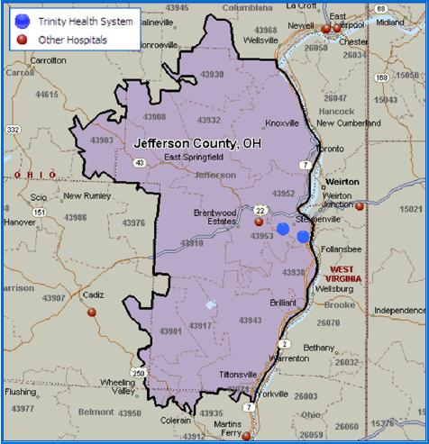



As of July 1, 2015, the population in Jefferson County is estimated to be 67,347, a 3.4% decrease from 2010. By 2018, this population is projected to decrease by 4.0 %. Across the state and country however, population has grown in number. 39% of the county is considered rural. While the largest portion of the population is made up of White Non-Hispanics (90.8%), in the next 5 years the only race/ethnic groups projected to have growth are the Hispanic and Multiracial populations.





The median age in Jefferson County is 44.3 years which is much higher compared to the state’s median age (39.1 years) and the country’s median age (37.4 years). Across the county, the number of people under the age of 18 years have decreased over the past five years. Whereas, the senior citizen population (65 years and older) has increased across the county, state and the country.



1.2% of the county’s population is made up of foreign-born persons, with 2.6% speaking languages other than English at home. An average household in the county consists of 2.32 members with median income of $40,816. 17.5% of the county’s population live in poverty, which is a much higher percentage when compared to the state (6.7%) and the country (15.6%). 17.9% of households across the county depended on food stamps or SNAP benefits over 2014. Though persons in Jefferson County live below the poverty line, the county’s unemployment rate (5%) is much lower compared to the rest of the state (5.8%) and the country (5.8%). 89.5% of the county’s population have graduated from high school and 15.2% have a Bachelor’s degree or higher.

## Health Outcomes

Health-Related Quality of Life (HRQoL) is a multi-dimensional concept that includes domains related to physical, mental, emotional, and social functioning. It goes beyond direct measures of life expectancy, and causes of death, and focuses on the impact that health status has on quality of life. [1] 18% of the county’s adult population (aged 18 years and older) report poor or fair health[2], with 4.1 physically unhealthy days [3] and 4.4 mentally unhealthy days. [4] The county recorded 10,700 years of potential life lost before the age of 75 years. Jefferson County performed worse than the state and the country in all measures and is ranked at 81 out of 88 counties in the state.

## Health Behaviors

Though 70% of the county’s adult population have adequate access to recreational facilities and exercise opportunities, 29% report no time for leisure activity and 34% of the county’s adult population was recorded as being obese.

Diabetes affects an estimated 23.6 million persons in the country and is the 7th leading cause of death. Out of 13% of adults in the county diagnosed with Diabetes, only 80% of the diabetic Medicare enrollees (aged 65 – 75 years) received diabetic monitoring. [5] 39.3 deaths per 100,000 population between 2005 and 2011 were attributed to Diabetes.

21% adults engage in smoking and 17% of adults in the county engage in binge-drinking leading to 40% of deaths in the county being attributed to alcohol-impaired driving. 27 deaths per 100,000 population were attributed to drug poisoning or overdoses.

86 persons per 100,000 population live with a diagnosis of human immunodeficiency virus (HIV) infection with 320.2 cases of Chlamydia (per 100,000 population) being diagnosed in 2013. 35 births per 1,000 females between 2007 and 2013 were born to females aged 15 – 19 years, and 8% of all live births in the county were babies born with very low birth weight (less than 2,500 grams).

## Clinical Care

13% of the county remains uninsured with adults making up 15% and children 5%. The amount of price-adjusted Medicare reimbursements per enrollee totaled up to $11,994 which was higher than health care costs across the country ($10,177). The county saw an average of 1 primary care physician for every 2,340 persons, 1 mental health provider for every 810 persons and 1 dentist for every 2,330 persons. [6]

## Social Health and Mortality

174 violent crime offenses were reported per 100,000 population leading to 7 homicides and 87 injury deaths per 100,000 population.

Analytics supplemented the publically available data with estimates of disease prevalence for heart disease and cancer, emergency department visit estimates, and the community need index.

Heart disease estimates indicate the majority of heart disease prevalence in the Trinity Health community has hypertension as the primary diagnosis (20,691 cases). Other diagnoses include ischemic heart disease (4,818 cases), arrhythmias (3,779 cases), and congestive heart failure (2,144 cases). Given the nature of heart disease there is significant co-morbidity between the diseases referenced above.

The 2013 cancer incidence estimates reveal at least 40 new cases of each of the following types of cancer: prostate, lung and breast. For the community served, 331 new cancer cases were diagnosed in 2013, and 203.6 cancer deaths per 100,000 population.

12.9% of the county’s population reported having Alzheimer’s contributing to 23.5 deaths per 100,000 population due to the disease. The county also recorded 18.1 chronic kidney disease deaths, 44.3 stroke deaths, and 245.6 major heart disease deaths. [7]

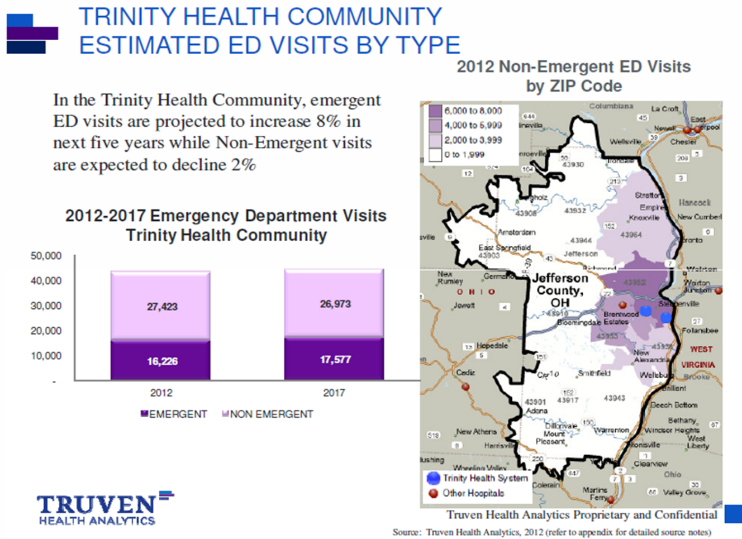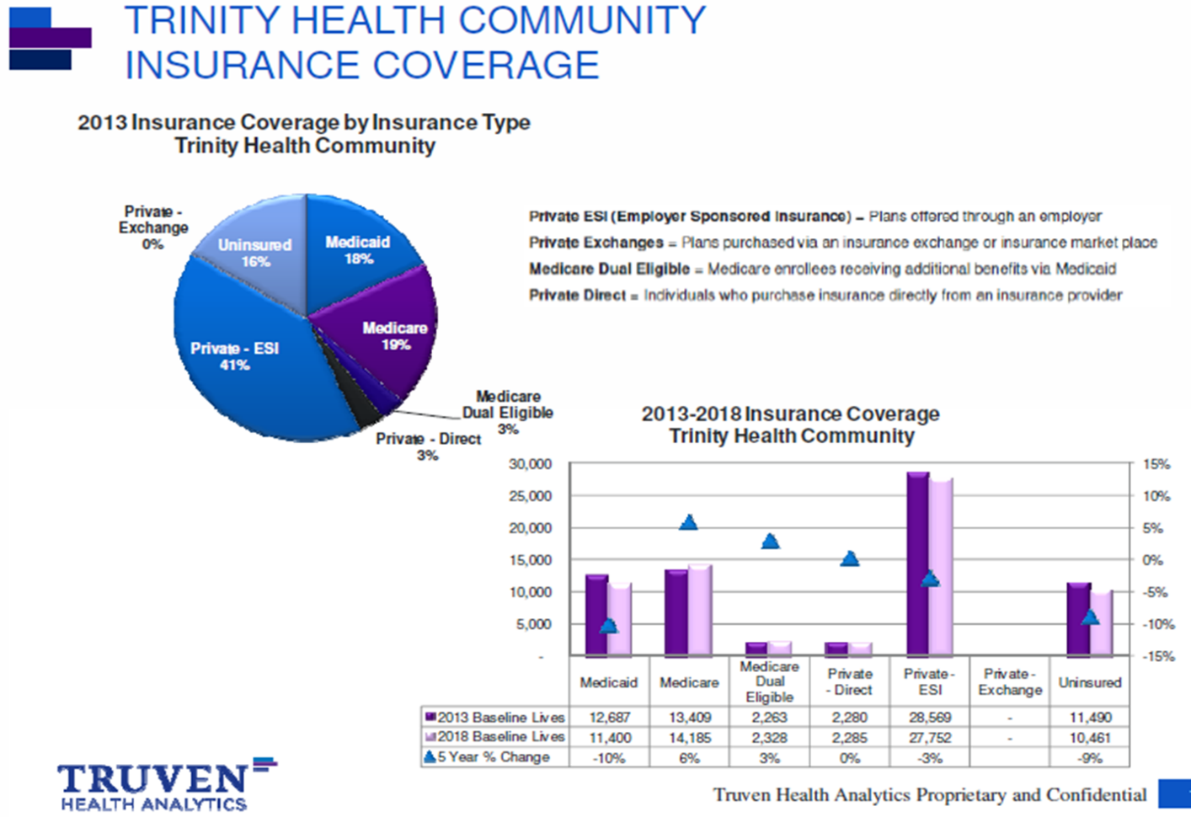

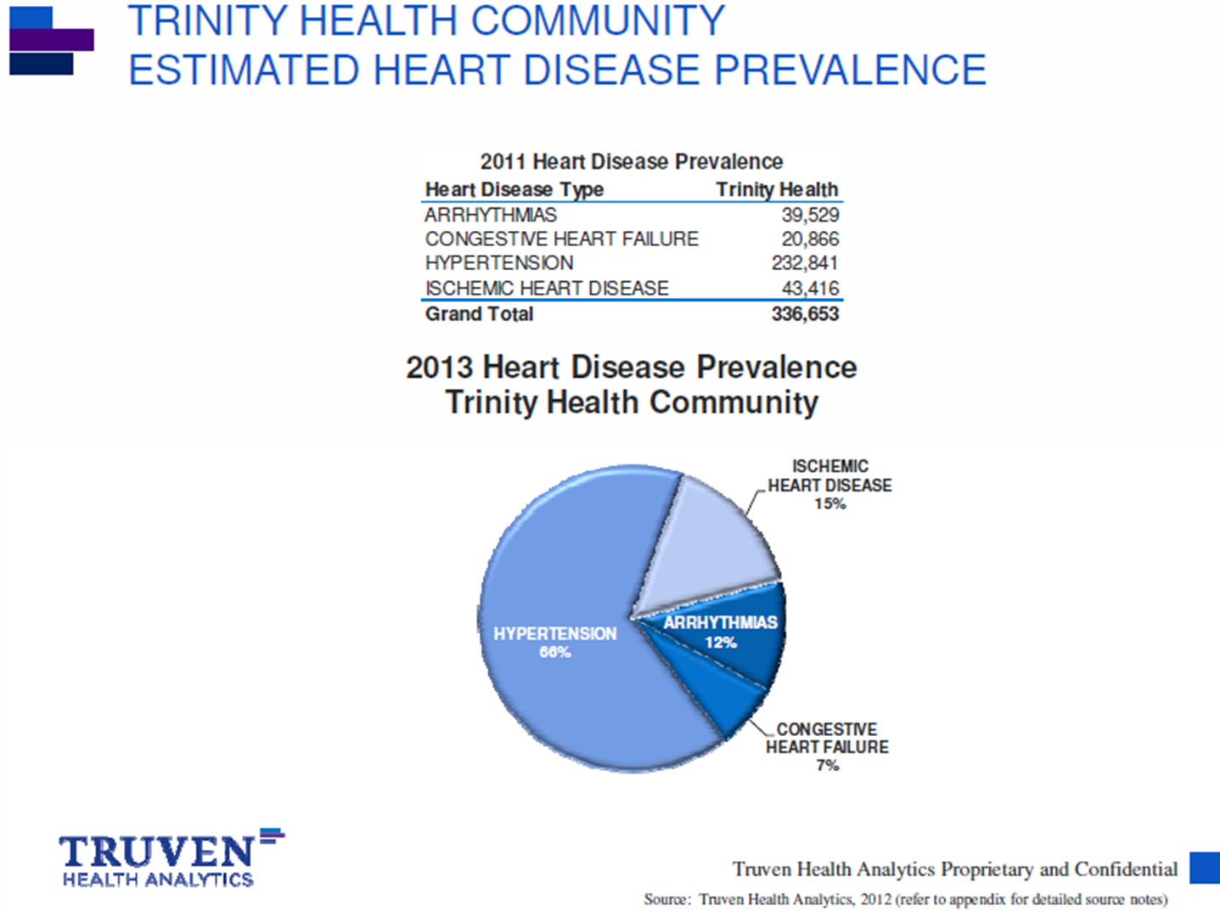

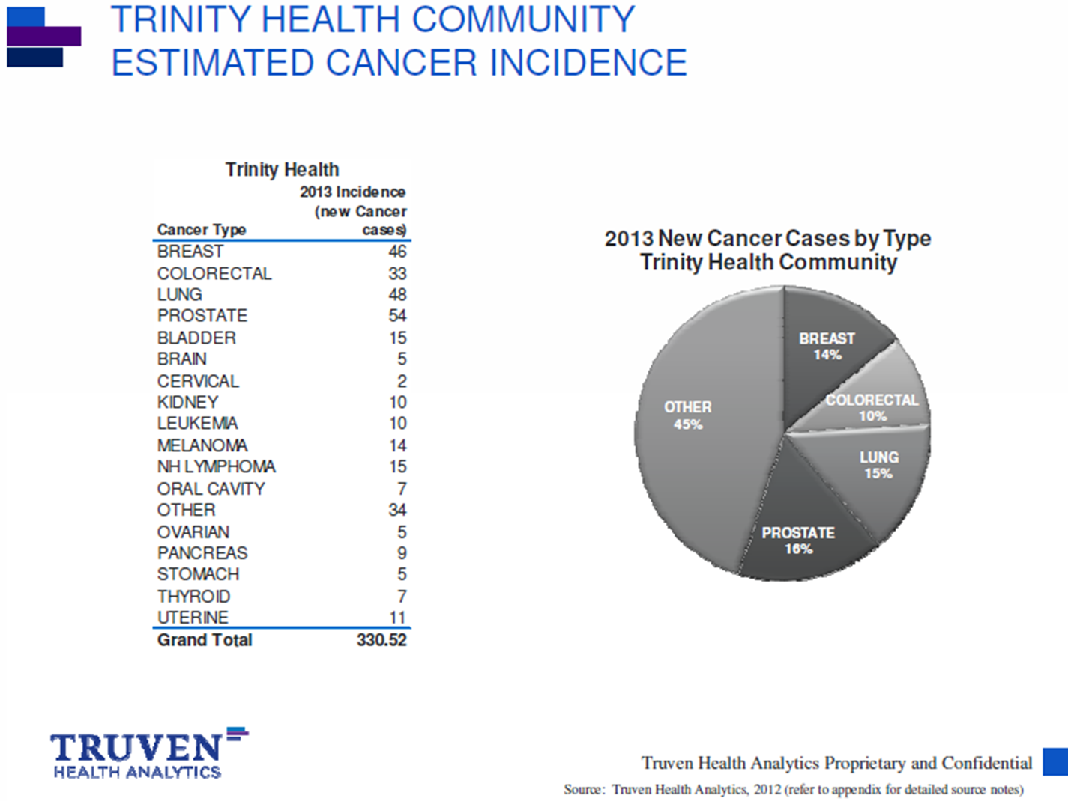

# Appendix A: Community Resources to Address Significant Health Needs

|  |  |  |  |  |
| --- | --- | --- | --- | --- |
| **Program Name** | **Description** | **Website** | **Phone Number** | **Health Need** |
| 4th Street Health Clinic | Provide quality healthcare to the uninsured adults of Jefferson County who are at 200% federal poverty level. Provide screenings, education, referrals and prescription assistance. | [www.jcfshc.org](http://www.jcfshc.org) | 740-283-2856 | Access to Care |
| A.L.I.V.E. Shelter | A.L.I.V.E. provides shelter and services for domestic violence and dating violence victims. | www.unitedway- [jc.org/members.html](http://jc.org/members.html) | 740-283-3444 | Socio-economic |
| Adena United Methodist Church | Food Pantry | n/a | 740-546-3785 | Socio-economic |
| AIM Women’s Center | Women’s clinic with services including pregnancy test, ultrasound, medical/legal referral, adoption information, educational programs, and post abortion healing retreats. | [www.aimwomenscenter.com/ser](http://www.aimwomenscenter.com/ser) vices | 740-283-3636 | Teen Pregnancy |
| Alcoholics Anonymous / Narcotics Anonymous | Support Groups | [area53aa.org](http://area53aa.org) [www.na.org](http://www.na.org) | 740-283-7020 | Behavioral Health, Overall Health Status |
| Alzheimer’s Association of Greater East Ohio | Alzheimer’s Support Group | [www.alz.org/akroncantonyoungs](http://www.alz.org/akroncantonyoungs) town/ | 740-264-5591 | Behavioral Health,  Overall Health Status |
| Area Agency on Aging Region 9 | AAA9 works with people, communities and organizations to educate, prepare and assist them in meeting the needs of aging. Program and resources include: assisted living, care coordination, care-giver support and education, long-term care consultation, pre-admission review, energy assistance, and adult protective services. | [www.aaa9.org](http://www.aaa9.org) | 800-945-4250 | Access to Care, Overall Health Status, Socio-economic |
| Autism Society of America | Support Groups | [www.autism-society.org](http://www.autism-society.org) | 740-537-4718 | Behavioral Health,  Overall Health Status |
| Better Breathers Club | COPD Support Group | [www.trinityhealth.com/calendar/](http://www.trinityhealth.com/calendar/) event/39/ | 740-264-8196  740-264-8098 | Behavioral Health,  Overall Health Status |
| Big Brother Big Sister | Big Brothers Big Sisters strive to provide positive role models to give today's youth hope and the courage to avoid negative peer pressure. | [www.bbbsjeff.org](http://www.bbbsjeff.org) | 740-264-3306 | Disadvantaged  Children |
| Blessed Sacrament Church | Food Pantry | [wintersvilleparishes.yolasite.co](http://wintersvilleparishes.yolasite.co) m/ | 740-264-9547 | Socio-economic |
| Breast Cancer Survivors Support Group | Support Group | [www.trinityhealth.com/program](http://www.trinityhealth.com/program) s-services/additional- services/womens-health | 740-283-7407 | Behavioral Health,  Overall Health Status |
| Bureau for Children with Medical Handicaps (BCMH) | A health care program in the Ohio Department of Health (ODH). BCMH links families of children with special health care needs to a network of quality providers and helps families obtain payment for the services their children need. Located at the Jefferson County Health Department | [www.odh.ohio.gov/odhprograms /cmh/cwmh/bcmh1](http://www.odh.ohio.gov/odhprograms/cmh/cwmh/bcmh1) | 740-283-8541 | Disadvantaged  Children |
| CHANGE Inc. | CHANGE, Inc. encourages the integration of services, the building of partnerships, and the consolidating of resources to empower families towards healthy self- sufficient living. Services include medical care and health, housing, transportation, food, emergency and economic assistance. | [changeinc.org](http://changeinc.org) | 740-314-8258 | Access to Care,  Socio-economic,  Overall Health  Status |
| Charity Hospice | Grief Support Group | [www.charityhospice.org](http://www.charityhospice.org) | 740-264-3443 | Behavioral Health,  Overall Health Status |
| Community Action Council | The CAC is committed to restore and revitalize the quality of life in Jefferson County, and move the residents towards self-sufficiency. CAC adapts and provides programs that are accessible, affordable, and culturally-sensitive to meet the needs of the community. Programs include: Head Start, Senior Companions, Emergency Homeless Program, Emergency Medical Assistance, Home Energy Assistance Program (HEAP), adult and dislocated worker programs, Ohio Means Jobs, Senior Community Service Employment Program (SCSEP), housing programs, home buying programs, and Teen Parenting | [jeffersoncountycac.com](http://jeffersoncountycac.com) | 740-282-0971 | Socio-economic,  Disadvantaged  Children,  Overall Health  Status |
| DARE | D.A.R.E. provides students with the skills necessary to recognize and resist pressures to experiment with drugs and to avoid gangs and violence. The most important facet of D.A.R.E. is the use of specially trained police officers to deliver the curriculum within the schools. | [www.dare-oh.org](http://www.dare-oh.org); [www.cityofsteubenville.us/polic](http://www.cityofsteubenville.us/polic)e | 740-283-6000 | Disadvantaged  Children |
| Family & Children First | Ohio Family and Children First (OFCF) is a partnership of state and local government, communities and families that enhances the well-being of Ohio’s children and families by building community capacity, coordinating systems and services, and engaging families. | [www.fcf.ohio.gov](http://www.fcf.ohio.gov) | 614-752-4044 | Disadvantaged  Children, Socio-  economic, Overall  Health Status |
| Family Service Association | The Mission of the Family Service Association of Steubenville, Ohio is to strengthen and support families and individuals by providing quality Services which include: Mental Health Counseling, Guardianship, Representative Payee, and Licensed Child Care. | [www.facebook.com/pages/Famil](http://www.facebook.com/pages/Famil)y-Service-Association/424027760975659 | 740-283-4763 | Behavioral Health,  Disadvantaged  Children |
| Goodwill Industries of Greater Cleveland and East Central Ohio, Inc | Works to improve the quality of life and employment opportunities for all people. Services include employment and life skills (e.g. | [www.goodwillgoodskills.org/eas](http://www.goodwillgoodskills.org/eas) t-central-ohio | 800-942-3577 | Socio-economic |
| Heartland Health Fair | Designed as the "Largest Heart Risk Appraisal Under One Roof Trinity Health  System sponsors this program along with Prime Time Office on Aging to help  community members improve their health through screenings and information. | [www.trinityhealth.com](http://www.trinityhealth.com) | 740-264-8296 | Heart Disease/  Hyper-tension |

|  |  |  |  |  |
| --- | --- | --- | --- | --- |
| **Program Name** | **Description** | **Website** | **Phone Number** | **Health Need** |
| Help Me Grow | Help Me Grow is a home-based, child-development program. | [www.jchealth.com/helpmegrow](http://www.jchealth.com/helpmegrow) | 740-283-8530 | Disadvantaged  Children |
| Homeless Shelters | Cathedral Apartments Hutton House | n/a | 740-282-5150  740-282-8903 | Socio-economic |
| Jefferson County Behavioral Health System | Jefferson Behavioral Health System is a full service mental health and drug & alcohol treatment facility that offers services to adults, children, and families. Also provides Beacon House Safe Haven a permanent residential housing and services for homeless mentally ill adults who may find it difficult to secure and maintain housing. | [www.jcprb.org](http://www.jcprb.org) | 740-264-7751 | Behavioral Health |
| Jefferson County Children's Services | The Children Services Division is responsible for responding to reports of child abuse/neglect/dependency, Provides foster-care services, a children's home, and adoption services to children in need of alternative placement outside of the home. The Division works to maintain families while assuring child protection. | [www.jcdjfs.com/ChildrenServic](http://www.jcdjfs.com/ChildrenServic) es.aspx | 740-283-0961 | Disadvantaged  Children |
| Jefferson County Health  Department | Provide to Jefferson County General Health District residents WIC (women, infant, and child) programs including nutrition and breastfeeding classes, registered/licensed dietitian consults, nutrition collaboration with Head Start, hemoglobin testing and other educational talks. Public nursing services also provided to residents including infectious diseases, child and family health services, physicals, immunization, outreach clinics, blood pressure screenings, children with medical handicaps and flu immunizations. | [www.jchealth.com](http://www.jchealth.com) | 740-283-8530 | Access to Care, Prevention, Environment,  Conditions/Diseases, Behavioral Health, Socio-economic, Overall Health  Status |
| Lupus Support | Lupus Support Group | [www.lupus.org/ohio](http://www.lupus.org/ohio) | 740-282-8010 | Behavioral Health,  Overall Health Status |
| Mended Hearts | Heart Patient Support Group | [mendedhearts.org](http://mendedhearts.org) | 740-283-7210 | Behavioral Health,  Overall Health Status |
| Mobile Lab Services | Trinity Health System Go Lab Mobile | www.trinityhealth.com | 740-264-8185  740-632-7827 | Access to Care |
| Mom’s Meals | Meal Delivery Service | www.MomsMeals.com | 877-508-6667 | Access to Healthy Foods |
| Ohio Department of Health | Programs include: primary care and rural health, Primary Care Office, primary care physician recruitment, Safety Net Clinics (dental care), school-based dental sealant programs (S-BSPs), Preventive Health and Health Services Block Grant (PHHSBG), Uninsured Care Program, Ohio Adolescent Health Partnership (OAHP), WIC, Breast and Cervical Cancer Project, Comprehensive Cancer Control Program, Cancer Incidence Surveillance System (OCISS), Tobacco Use Prevention and Cessation Program, Ohio Heart Disease and Stroke Prevention (HDSP) Program, Ohio Diabetes Prevention and Control Program (ODPCP). | [www.odh.ohio.gov/atoz/atoz.asp](http://www.odh.ohio.gov/atoz/atoz.asp) x#p | 800-266-4346 | Access to Care, Prevention, Environment,  Conditions/Diseases, Behavioral Health, Socio-economic, Overall Health  Status |
| **Program Name** | **Description** | **Website** | **Phone Number** | **Health Need** |
| Other Shelters | Gill House  YWCA  Projects for Assistance in Transition from Homelessness (PATH) | www.facebook.com/pages/YWCA-Steubenville-Ohio/136078316502519  PATH: [pathprogram.samhsa.gov](http://pathprogram.samhsa.gov) | Gill House 740-282-5338  YWCA 740-282-1261  PATH 740-264-7751 | Socio-economic, Overall Health status |
| Overeaters Anonymous | Support group | www.oa.org | 740-264-2424 | Behavioral Health, Overall Health Status |
| PrimeTime | Mission is to keep PrimeTime members Healthy Independent and Productive (HIP) as they age. Services include: meals, transportation for medical appointments, legal assistance, health education and exercise, safety, mobile medical screenings, and Parkinson’s Support group | [www.facebook.com/PrimeTime](http://www.facebook.com/PrimeTime) OfficeOnAging | 740-283-7470 | Access to Care, Lifestyle/Prevention, Environment, Socio-economic, Overall Health Status |
| Reach to Recovery | Breast Cancer Patient Support Group | [www.trinityhealth.com/program](http://www.trinityhealth.com/program) s-services/additional- services/womens-health | 740-283-7407 | Behavioral Health, Overall Health Status |
| Red Cross | Disaster assistance: shelter, meals, health and mental services, and emergency preparedness | www.redcross.org/oh/wintersville | 740-264-7244 | Behavioral Health, Overall Health Status |
| Smoking Cessation Program | Smoking Cessation Support Group | [www.trinityhealth.com/calendar/](http://www.trinityhealth.com/calendar/) event/29/ | 740-264-8196  740-264-8098 | Behavioral Health,  Overall Health  Status |
| Soup Kitchens | Holy Name Cathedral  St. Paul's Episcopal Church Urban Mission | n/a | 740-264-6177  740-282-5366  740-282-8010 | Socio-economic |
| The Salvation Army | The Salvation Army in Steubenville is dedicated to serving the men, women, and children who are at-risk and in need of financial, social service, and spiritual support. In teaching life skills, Salvation Army provides individuals with an opportunity to maximize their physical, emotional, and spiritual being to effect life change. | [www.use.salvationarmy.org](http://www.use.salvationarmy.org) | 740-282-5121 | Socio-economic |
| Trinity  ExpressCare | Offers express services for such things as colds, flu, rashes, stitches and fractures. Referrals to any area specialist for advanced care. | [www.trinityhealth.com/program](http://www.trinityhealth.com/program) s-services/outpatient-services/trinity-expresscare | 740-346-2702 | Access to Care |
| Trinity Health Behavioral Health Medicine | Provide inpatient and outpatient behavioral health and addiction recovery services | [www.trinityhealth.com](http://www.trinityhealth.com) | 740-264-8296 | Behavioral Health |

|  |  |  |  |  |
| --- | --- | --- | --- | --- |
| **Program Name** | **Description** | **Website** | **Phone Number** | **Health Need** |
| Trinity Health Pastoral Care | Grief Support Group | [www.trinityhealth.com](http://www.trinityhealth.com) | 740-264-8130 | Behavioral Health,  Overall Health Status |
| United Way of Jefferson County | United Way allows for the financial support of 18 member agencies and programs through monthly allocation distributions. United Way increases the organized capacity of people to care for one another through the support of the local United Way agency. In March 2013 the Jefferson County United Way 211 Information & Referral System became operational. | www.unitedway- [jc.org/index.html](http://jc.org/index.html) | 740-284-9000 | Overall Health Status |
| Upper Ohio Valley Sexual Assault Help Center | Support Group | n/a | 740-282-6022 | Behavioral Health,  Overall Health  Status |
| Urban Mission | The Urban Mission is the one of the largest charities in the Upper Ohio Valley, offering food, shelter and other essential services to our community's low income families. Provide hunger relief, shelter for families, hot meals, furniture, clothing and spiritual care. | [www.urbanmission.org](http://www.urbanmission.org) (Note: website under construction) [www.facebook.com/UrbanMissi](http://www.facebook.com/UrbanMissi) onInc/info | 740-282-8010 | Socio-economic |
| Valley Hospice | S.H.A.R.E of the Upper Ohio Valley – support for those who have experienced a loss during pregnancy/childhood. | [www.valleyhospice.org](http://www.valleyhospice.org) | 304-233-4778 | Behavioral Health,  Overall Health Status |
| Valley Hospice Compassionate Friends | Community Grief Support Group | [www.valleyhospice.org](http://www.valleyhospice.org) | 740-284-4440 | Behavioral Health,  Overall Health Status |
| Veterans Services Commission | Provides temporary financial assistance to needy veterans, dependents, and/or widows. Eligibility and verification of a definite financial need is determined through the application process. Assistance is provided through food orders and cash vouchers. | [www.jeffersoncountyoh.com/Co](http://www.jeffersoncountyoh.com/Co) untyOffices/VeteransServiceCo mmission.aspx | 740-283-8571 | Socio-economic |
| YMCA | The YMCA is a membership organization dedicated to improving the quality of life in our community. Through programs, service and leadership, the YMCA promotes ethical values that contribute to its members’ growth in building healthy spirits, minds and bodies. The YMCA is open for all, providing financial assistance to those in need. Programs include fitness facilities and classes, wellness orientations and cardio-strength centers, and reduced cost for youth and adult sports programs. | [www.ymcanet.org/Steubenville](http://www.ymcanet.org/Steubenville) | 740-264-7183 | Lifestyle/  Prevention, Overall  Health Status |
| YWCA | YWCA is dedicated to eliminating racism and empowering women. Programs include job training, financial literacy, childcare programs, scholarships and more. | [www.ywca.org](http://www.ywca.org) | 740-282-1261 | Socio-economic |

Community Health Needs Assessment

Accomplishments for FY 2017

The following is a compilation of the achievements of the Trinity Health System as part of the Community Health Needs Assessment Implementation Plan during FY 2017. Three Issues were selected as the most pressing needs: Mental Health and Substance Abuse, Wellness and Prevention and Access to Primary Care.

**Mental Health and Substance Abuse**

1. Partner with local Mental Health Board to increase access
   1. Create ambulatory detox program
      1. Program put on hold due to staffing, space and funding issues. Trinity continues to provide the only inpatient detox service in our 8-bed inpatient detox unit.
   2. Expand residential program
      1. Received approval to expand residential beds.
      2. No additional funding from local Board was obtained so expansion of residential unit did not take place.
      3. Residential unit was closed on May 26, 2016 after funding from local Board was discontinued.
      4. A new business model was developed to evaluate the possibility of providing residential treatment without outside funding. Re-opened on December 12, 2016 with a 4-bed unit.
   3. Add additional services
      1. Transitions Program for opioid addicted mothers-February 2015
      2. Relapse Prevention Group-November of 2015
      3. School-based counseling services-September 2016
   4. Formed Opioid Task Force-November 2016
      1. 11/17/16 Bob Fowler, Director of Brooke County EMS. Meeting at Trinity with Bob and his Assistant.
      2. 12/19/16 Meeting with local judges, Joe Tasse, Don Ogden to discuss the opioid addiction issue, which resulted in collaboration on court placements in Trinity’s residential program beds. Trinity now has court navigators in the various courts.

John J. Mascio, Municipal Court

Dave Scarpone, County Court

Lisa Ferguson, County Court

Mike Bednar, County Court

* + 1. 2/9/17 106.3 The River radio interview at Heartland and Channel 5 News spot by J. Tasse on the opioid epidemic in our area, increasing community awareness on this serious problem in our community.
    2. 2/21/17 Jefferson County Schools Education Session, by Don Ogden, Dr. Figel, Dr. Columbus, J. Tasse with school superintendents, teachers, athletic directors and Chuck Kokiko, Jeff County School Superintendent; on the opioid crisis in the schools.
    3. 3/20/17 EMS Meeting with D. Ogden, J. Mulrooney, Dr. Columbus, D. Louk, A. Lindsey, J. Tasse, improving communication among the pre-hospital care community and Trinity Health System to improve healthcare access:

Weirton Area Ambulance and Rescue Squad, Inc. (WAARS)

Bud Cole, Chief

Rick Antol, Supervisor/Squad Training Officer

New Cumberland Ambulance Service

Joe Polgar, Owner

Matt Cashdollar, EMS Supervisor

* + 1. 3/30/17 Commissioner Dave Maple with D. Ogden, J. Mulrooney, J. Tasse re: Jefferson County Prevention and Control Board (317) funding opportunities
    2. 4/6/17 106.3 The River, Radio Interview on Opioid Crisis, with Joe Tasse by Joey Klaypek, further communicating to the community regarding the epidemic we are facing.
    3. 5/9/17 EMS Squad Meeting with J. Mulrooney, D. Louk, Dr. Columbus, Dr. Figel, A. Lindsey

Mingo Junction Fire Department/EMS

John D. Wright, Chief

Jim Raha, Assistant Chief

Toronto TEMS Joint Ambulance District

Chief Clark Crago

Ambulance Service Inc.

Bob Herceg

* + 1. 5/10/17 Community Mental Health Providers Coordinating Meeting

Jefferson County Prevention and Recovery Board (317 Board)

Pam Petrilla, Director

Dan Obertance, Associate Director

Family Recover Center

Eloise Traina, CEO

Jefferson County Coleman Professional Services

Nelson Burns, CEO

Lisa Ward, Chief Officer

Trinity Health System

Don Ogden, Director, Behavioral Health

JoAnn Mulrooney, COO

Joe Tasse, Interim President & CEO

1. Identify and/or organize support groups
   1. Created list of AA/NA meetings in area
      1. Communicated with Chairpersons of AA/NA meetings held at Trinity
   2. Obtained list of Grief Support Groups
   3. Started Aftercare Group for patients discharged from Mood Disorders Program
   4. Collaborated with Sexual Anonymous members to start a meeting at Trinity
   5. Collaborated with Gamblers Anonymous members to start a meeting at Trinity
2. Develop Emergency Department Liaison
   1. Position not approved, but collaborated with Jefferson Behavioral Health System to provide liaison services.
   2. Awaiting approval for community Medicaid status to be able to provide and bill for case management services in the emergency room as well as the primary care offices.

**Prevention and Wellness**

1. Conducted health screenings
   1. Heartland 2017
      1. Screened 1,000 individuals with a comprehensive blood analysis.
   2. Monthly Blood Screenings
      1. Screened 450 individuals with a comprehensive blood analysis at Prime Time Center at monthly screenings.
   3. Skin Cancer Screenings
      1. Conducted three Skin Cancer Screenings with Dr. Oser in March, April and May, 2017.
   4. Prostate Screening
      1. Screened 57 individuals at the yearly Minority Health Day.
   5. Colon Cancer Screening
      1. Offered 30 free colonoscopies to under-served and under-insured population in March, 2017.
   6. Nutrition
      1. Provided monthly nutrition counseling at YMCA.
   7. The Cancer Dietary Initiative at the Teramana Cancer Center – Provides food baskets to 100 patients per month. Fit for Life.
      1. Continued the Fit for Life Program in conjunction with Dr. McKnight and YMCA.
   8. Freedom From Smoking
      1. Offered monthly smoking cessation courses for 130 individuals.
   9. Better Breathers
      1. Offered monthly educational opportunities for individuals with COPD.
   10. Weight Loss
       1. Offered monthly weight loss programs in conjunction with Dr. Colella and the Bariatric Program

**Access to Primary Care**

1. In fiscal 2017, we added two new Primary Care physicians:

a. Porsche Beetham, MD – Family Practice

b. Maria Tranto, DO – Internal Medicine

2. In fiscal 2017, we also added several Advanced Practice Providers to improve access to primary care:

a. Melissa Buksa, CNP, joined Mark Kissinger, MD – Family Practice

b. Lindsey Lee, CNP, joined Matt Colflesh, MD – Internal Medicine

c. Melody Wright, CNP, joined John Figel, MD – Family Practice

3. In fiscal 2017, we added / completed the opening of our Express Clinic (Walk-In, Same Day APP Primary Care) in Calcutta (where we now see an average of 25 patients a day).

a. Our Express Care Walk-In clinic in Wintersville continues to grow and is now seeing an average of 75 patients per day.

b. Our Express Walk-In Clinic in Toronto continues to grow and is now serving an average of 25 patients per day.

c. In 2017, a multi-disciplinary team has worked to design a new Primary Care / Express Clinic for Cadiz, expected to open late FY 2018 / early fiscal 2019. Plans are complete and construction has started. We will have both Primary Care physicians and Advanced Practice Providers proving care at this new location.

4. Through 10 months FY 2017 (compared to FY 2016), primary care visits are up 12%, 98,295 (2017) versus 83,342 (2016).

5. In FY 2017, we added a Continuity Clinic at the Hospital to provide post discharge outpatient follow up and medication reconciliations for patients who were either “unassigned” (no primary care physician) or could not get an appointment with their primary care physician with 5 to 10 days after discharge from the hospital.

6. In FY 2018 we introduced 1-844-TPG – Call, an 800 number for people looking to find a primary care physician. This Call Center fields between 75 and 100 calls per month and has an 80% placement result so far.

7. We are working to better integrate Primary Care with our Behavioral Health Program and our Pain Medicine Program, two overwhelming health issues growing daily in this region and around the country.

June 2017

**Community Health Needs Assessment Implementation Plan**

**Trinity Health System**

**Three-Year Plan: FY 2017, FY 2018, FY 2019**

**Mission**

The mission of Catholic Health Initiatives (CHI) and the Trinity Health System (Trinity) is to nurture the healing ministry of the Church, supported by education and research. Fidelity to the Gospel urges us to emphasize human dignity and social justice as we create healthier communities.

**Community Served**

In order to define the community served, Trinity evaluated the total population, inpatient discharges, Ohio/West Virginia, Pennsylvania inpatient discharges, and Medicare market share for the surrounding counties. Trinity is dependent on Jefferson County for 71% of its inpatient discharges. A review of Medicare data also indicates that the majority of Medicare patients (60% market share) who reside in Jefferson County, seek services at Trinity. The surrounding counties are each served by other providers in the region. Therefore, for the purposes of this report, the Trinity Health System community served is defined as Jefferson County.

**Prioritized List of Significant Health Needs Identified in the Community Health Needs Assessment (CHNA)**

* Mental Health & Substance Abuse
* Wellness & Prevention
* Access to Primary Care

**Other Identified Needs**

* Diabetes
* Sexually Transmitted Diseases
* Homicides
* Heart Disease

Trinity Health System addresses Diabetes through our hospital and physician services, and, in particular, is a component of the cardiovascular and bariatric programs. In addition, heart disease prevention is part of wellness and prevention and is included in this section. However, given limited resources, this need has not been chosen as a separate program area of focus under this plan. Trinity also does not have the resources to provide a comprehensive STD program and there are aspects of a STD program which could be counter CHI’s Ethical and Religious Directives. The local health department provides community services in this area. Additionally, CHI does work in the area of violence prevention but does not have the resources or expertise to create a separate program to focus on lowering homicide rates in the county.

|  |  |
| --- | --- |
| **Community Health Need** | **Mental Health & Substance Abuse** |
| Trinity Health Point Person(s) | Don Ogden, Director of Behavioral Health |
| Metric #1 | Average Number of reported mentally unhealthy days per month for Jefferson County BRFSS respondents age 18+ |
| 2016 CHNA Measure | Jefferson County: 4.4 (2005 - 2011); Ohio State Benchmark: 3.8 (2005 - 2011) |
| Data Source | CDC, Behavioral Risk Factor Surveillance System (BRFSS); also reported via County Health Rankings |
| Metric #2 | Percent of Jefferson County BRFSS respondents age 18+ who report not receiving sufficient social - emotional support |
| 2016 CHNA Measure | Jefferson County: 27.6% (2005 - 2010); Ohio State Benchmark: 19.8% (2005 - 2010) |
| Data Source | CDC, Behavioral Risk Factor Surveillance System (BRFSS); also reported via County Health Rankings |

|  |  |  |  |  |  |  |  |  |
| --- | --- | --- | --- | --- | --- | --- | --- | --- |
| **Implementation Plan – Mental Health & Substance Abuse** | | | | | | | | |
| **#** | **Action  (owner)** | **Anticipated Impact of Action** | **Metric (s)** | **Action Timeline (provide date)** | **Stakeholder Support Needed** | **Steps to Achieve** | | **Step Estimated Completion Date** |
|
| 1 | Partner with local Mental Health Board to increase access.  *(Don Ogden)* | Create an ambulatory detox program and expand residential services. | Fully implemented ambulatory detox and expanded residential programs. | June 30, 2017 | Administration, Mental Health Board | 1 | Meet with local Mental Health Board. | August 31, 2018 |
| 2 | Secure funding for program development and expansion. | October 31, 2018 |
| 3 | Meet with Administration to present program plan. | August 31, 2018 |
| 4 | Develop and implement programs. | June 30, 2018 |
| 2 | Develop gambling addiction services  *(Don Ogden)* | Creating access to services for those in need | Fully implemented services for gambling addiction | June 30, 2017 | Administration, Gamblers Anonymous State Agencies | 1 | Site visit of existing gambling treatment center. | September 30, 2018 |
| 2 | Identify program standards for program development. | October 31, 2018 |
| 3 | Secure funding for program development. | February 28, 2018 |
| 4 | Implement program. | June 30, 2018 |
| 5 | Implement marketing strategy for services. | September 30, 2018 |

|  |  |  |  |  |  |  |  |  |
| --- | --- | --- | --- | --- | --- | --- | --- | --- |
| **Implementation Plan – Mental Health & Substance Abuse** | | | | | | | | |
| **#** | **Action  (owner)** | **Anticipated Impact of Action** | **Metric (s)** | **Action Timeline (provide date)** | **Stakeholder Support Needed** | **Steps to Achieve** | | **Step Estimated Completion Date** |
|
| 3 | Identify and/or organize support groups.  *(Don Ogden)* | Increase and support access. | 12 Support Groups | September 30, 2017 | Local support groups, Clergy, Community volunteers | 1 | Identify present support groups and perform gap analysis. | December 31, 2018 |
| 2 | Identify capacity and resources to conduct additional support groups. | March 31, 2018 |
| 3 | Provide education and training to facilitators. | June 30, 2018 |
| 4 | Implement marketing strategy for services. | September 30, 2018 |
| 4 | Develop Emergency Department Liaison.  *(Don Ogden)* | Increase access to behavioral health services. | Approval and recruitment of 1.0 FTE | June 30, 2017 | Administration, ED, Local Community, Mental Health Board | 1 | Develop job description for position. | December 31, 2018 |
| 2 | Meet with Administration to present need for FTE. | December 31, 2018 |
| 3 | Meet with Emergency Department staff. | March 31, 2018 |
| 4 | Post and recruitment for new position. | June 30, 2018 |

|  |  |
| --- | --- |
| **Community Health Need** | **Prevention & Wellness** |
| Trinity Health Point Person(s) | JoAnn Mulrooney, COO  Keith Murdock, Director of Community Relations |
| Metric | Jefferson County average number of mentally unhealthy days reported in the past 30 days (age-adjusted) |
| 2016 CHNA Measure | Jefferson County: 87.4% (2007 - 2009); Ohio State Benchmark: 79.1% (2007 - 2009) |
| Data Source | CDC, Behavioral Risk Factor Surveillance System (BRFSS) |

|  |  |  |  |  |  |  |  |  |
| --- | --- | --- | --- | --- | --- | --- | --- | --- |
| **Implementation** **Plan – Prevention & Wellness** | | | | | | | | |
| **#** | **Action  (owner)** | **Anticipated Impact of Action** | **Metric (s)** | **Action Timeline (provide date)** | **Stakeholder Support**  **Needed** | **Steps to Achieve** | | **Step Estimated Completion Date** |
|
| 1 | Continue partnership with Prime Time Meals on Wheels.  *(Judy Owings)* | Provide balanced meals to the community members in need. | 56,276 meals | December 31, 2017 | Administration, Prime Time | 1 | Track meals served quarterly. | January 31, 2019 |
| 2 | Work with stakeholders on understanding if there are existing gaps in Meals on Wheels program. | March 31, 2018 |
| 3 | Secure funding for program expansion or enhancement, if needed. | June 30, 2018 |
| 2 | Provide education and evaluate food choices offered on Trinity campuses. *(Bryan Jenkins)* | Help staff, patients and visitors make better choices about food. | Over 10,000 sessions | December 31, 2017 | Employee Health | 1 | Develop or invest in information brochures on how to read food labels and making better food choices. | March 31, 2018 |
| 2 | Evaluate feasibility of nutrition coaching for employees. | June 30, 2018 |
| 3 | Work with Food Services on providing nutritional information for each meal served. | June 30, 2018 |
| 4 | Work with Food Services to evaluate healthier cafeteria options for staff, patient and visitors. | June 30, 2018 |
| 5 | Evaluate vending machine options throughout facilities and work with supplier on stocking with healthier options. | September 30, 2018 |

|  |  |  |  |  |  |  |  |  |
| --- | --- | --- | --- | --- | --- | --- | --- | --- |
| **Implementation** **Plan – Prevention & Wellness** | | | | | | | | |
| **#** | **Action  (owner)** | **Anticipated Impact of Action** | **Metric (s)** | **Action Timeline (provide date)** | **Stakeholder Support**  **Needed** | **Steps to Achieve** | | **Step Estimated Completion Date** |
|
| 3 | Evaluate partnership with local Farmer's Market.  *(Judy Owings)* | Support local businesses that provide healthy food options to community. | Improve metric "limited access to healthy foods" | December 31, 2017 | Trinity Leader, Local Farmer's Market Organizer/  Contact | 1 | Contact Local Farmer's Market organizer to evaluate opportunities to work together. | March 31, 2018 |
| 2 | Secure funding for program development, if needed. | September 30, 2018 |
| 3 | Jointly develop programs that address better eating habits, nutrition and impact on long-term health. | December 31, 2018 |
| 4 | Promote partnership/coordination efforts on Trinity Health's Facebook Page. | December 31, 2018 |
| 4 | Provide education and nutrition counseling. *(YMCA/Trinity)* | Improve nutrition education and food choices. | 12 Programs | December 31, 2017 | Trinity, YMCA | 1 | Inventory current nutrition programs in the community. | March 31, 2018 |
| 2 | Gather stakeholders of programs to discuss coordinating efforts on community education directed at nutrition. | June 30, 2018 |
| 3 | Develop 2 co-sponsored programs targeted at nutrition education. | September 30, 2018 |
| 4 | Promote partnership/coordination efforts on Trinity Health's Facebook Page. | December 31, 2018 |

|  |  |
| --- | --- |
| **Community Health Need** | **Prevention & Lifestyle - Smoking** |
| Trinity Health Point Person(s) | JoAnn Mulrooney, COO  Keith Murdock, Director of Community Relations |
| Metric | Percent of Jefferson County respondents age 18+ who report smoking cigarettes all or some days |
| 2016 CHNA Measure | Jefferson County: 28.5% (2005 - 2011); Ohio State Benchmark: 21.7% (2005 - 2011) |
| Data Source | CDC, Behavioral Risk Factor Surveillance System (BRFSS); also reported via County Health Rankings |

|  |  |  |  |  |  |  |  |  |
| --- | --- | --- | --- | --- | --- | --- | --- | --- |
| **Implementation Plan – Prevention & Lifestyle - Smoking** | | | | | | | | |
| **#** | **Action  (owner)** | **Anticipated Impact of Action** | **Metric (s)** | **Action Timeline (provide date)** | **Stakeholder Support Needed** | **Steps to Achieve** | | **Step Estimated Completion Date** |
|
| 1 | Continue sponsorship of *Freedom from Smoking* program. *(Stacie Straughn)* | Reduce the rate of smoking in the community. | Increase the # of participants in the program by 10%. | December 31, 2017 | Trinity | 1 | Evaluate current marketing efforts of Freedom from Smoking Program. | March 31, 2018 |
| 2 | Explore grant funding or sponsorship to subsidize the program in an effort to increase participation. | June 30, 2018 |
| 3 | Reach out to employer partners through Occupational Medicine program to expand Freedom from Smoking program. | September 30, 2018 |
| 4 | Develop marketing strategy to increase participation (utilize social media, email blasts, print, etc.). | December 31, 2018 |
| 5 | Develop marketing strategy to increase participation (utilize social media, email blasts, print, etc.). | March 31, 2018 |
| 2 | Develop or re-engineer existing programs to target population with known smoking status. | June 30, 2018 |

|  |  |  |  |  |  |  |  |  |
| --- | --- | --- | --- | --- | --- | --- | --- | --- |
| **Implementation Plan – Prevention & Lifestyle - Smoking** | | | | | | | | |
| **#** | **Action  (owner)** | **Anticipated Impact of Action** | **Metric (s)** | **Action Timeline (provide date)** | **Stakeholder Support Needed** | **Steps to Achieve** | | **Step Estimated Completion Date** |
|
| 2 | Evaluate partnership opportunities with other community organizations that have smoking cessation programs. *(Stacie Straughn)* | Improve coordination of efforts to improve community health. | # of jointly hosted programs; increase participation by 10% | December 31, 2017 | Trinity American Lung Association | 1 | Inventory other smoking cessations programs in the community. | March 31, 2018 |
| 2 | Host stakeholder discussion on ways to improve the coordination of smoking cessation programs. | June 30, 2018 |
| 3 | Explore joint grant funding to subsidize programs. | September 30, 2018 |
| 4 | Develop and implement joint smoking cessation programs. | December 31, 2018 |
| 5 | Develop marketing strategy to increase participation (utilize social media, email blasts, print, etc.). | March 31, 2018 |
| 3 | Work with internal stakeholders to coordinate efforts on smoking cessation. *(Stacie Straughn)* | Target smoking cessation efforts on discharged patients with known smoking status. | Reduce rate of smoking in patient population by 10% | December 31, 2017 | Trinity | 1 | Conduct internal stakeholder meeting to explore coordination of smoking cessation efforts. | March 31, 2018 |
| 2 | Develop or re-engineer existing programs to target population with known smoking status. | June 30, 2018 |

|  |  |
| --- | --- |
| **Community Health Need** | **Prevention & Lifestyle – Lack of Exercise** |
| Trinity Health Point Person(s) | JoAnn Mulrooney, COO  Keith Murdock, Director of Community Relations |
| Metric | Percent of Jefferson County adult population that during the past month did not participate in any physical activity or exercise |
| 2016 CHNA Measure | Jefferson County: 33.3% (2008 - 2010); Ohio State Benchmark: 26.2% (2008 - 2010) |
| Data Source | CDC, National Center for Chronic Disease Prevention and Health Promotion; also reported via County Health Rankings |

|  |  |  |  |  |  |  |  |  |  |
| --- | --- | --- | --- | --- | --- | --- | --- | --- | --- |
| **Implementation Plan** | | | | | | | | | |
| **#** | **Action  (owner)** | **Anticipated Impact of Action** | | **Metric (s)** | **Action Timeline (provide date)** | **Stakeholder Support Needed** | **Steps to Achieve** | | **Step Estimated Completion Date** |
|
| 1 | Evaluate exercise class for new moms (post-partum).  *(Yvonne Rozman)* | Increase physical activity options for new moms. | | 300 participants | December 31, 2017 | Trinity, YMCA, Birth Center | 1 | Develop program with stakeholders. | March 31, 2018 |
| 2 | Identify space and Instructor(s) for exercise class. | March 31, 2018 |
| 3 | Coordinate marketing efforts with YMCA and Birth Center. | June 30, 2018 |
| 2 | Continue sponsorship of *P3* program. *(Justin Baker, DO)* | Improve physical fitness of program enrollees. | | Pre- and post-blood work results; Enrollment | December 31, 2017 | Trinity, YMCA | 1 | Evaluate current program enrollment. | March 31, 2018 |
| 2 | Track pre- and post-program blood work results of past enrollees to establish baseline goals of enrollees going forward. | June 30, 2018 |
| 3 | Evaluate grant/funding options to subsidize program participation. | September 30, 2018 |
| 4 | Develop marketing plan to increase enrollment | December 31, 2018 |
| 3 | Provide general physical fitness education. *(Justin Baker, DO)* | Emphasize importance of physical fitness to community. | | # of articles; # of Facebook posts/week; # of education classes | December 31, 2016 | Trinity, YMCA | 1 | Inventory current media efforts to community. | March 31, 2018 |
| 2 | Develop campaign that focuses on physical fitness. | June 30, 2018 |
| 3 | Execute coordinated marketing efforts using the most appropriate channels (social media, print, email, etc.) to educate the community. | September 30, 2018 |
| **COMMUNITY HEALTH NEED** | | | **Access to Primary Care** | | | | | | |
| Trinity Health Point Person(s) | | | Steve Brown, VP, MSO | | | | | | |
| Metric #1 | | | Jefferson County overall cancer death rate (per 100,000 age-adjusted) | | | | | | |
| 2016 CHNA Measure | | | Jefferson County: 188.4 (2010 age-adjusted); Ohio State Benchmark: 187.3 (2010 age-adjusted) | | | | | | |
| Data Source | | | Ohio Department of Health, Death Statistics | | | | | | |
| Metric #2 | | | Jefferson County invasive cancer incidence rate (per 100,000 age-adjusted) | | | | | | |
| 2016 CHNA Measure | | | Jefferson County: 539.8 (2008 age-adjusted); Ohio State Benchmark: 465.1 (2008 age-adjusted)* | | | | | | |
| Data Source | | | Ohio Cancer Incidence Surveillance System (OCISSHS) | | | | | | |

|  |  |  |  |  |  |  |  |  |
| --- | --- | --- | --- | --- | --- | --- | --- | --- |
| **Implementation Plan – Access to Primary Care** | | | | | | | | |
| **#** | **Action  (owner)** | **Anticipated Impact of Action** | **Metric (s)** | **Action Timeline (provide date)** | **Stakeholder Support Needed** | **Steps to Achieve** | | **Step Estimated Completion Date** |
|
| 1 | Continue to recruit PCPs and APC primary care providers. *(Steve Brown)* | Better access to PCPs | Primary care visits | December 31, 2017 | Physician contacts, Inbound Marketing | 1 | Physician and APC recruitment: in 2016 and YTD 2017, we have added three Primary Care Physicians (Orlang, Tranto, Beetham) and four APC (Advanced Practitioners) primary care providers. | December 2018 |
| 2 | In calendar year 2017 (annualized) we have increased Primary Care Visits by 9,957 or 12% (98,295 in 2017 versus 83,342 in 2016. | December 2018 |
| 3 | Continue to recruit Primary Care physicians and primary Care APCs. With Inbound Marketing, Social Media, and other conventional tools we are attracting more candidates. | December 2018 |
| 4 | In addition to increasing visits, we are expanding our outreach to areas like East Liverpool and Cadiz, expanding our outreach. | December 2018 |
| 5 | Planning another expansion to the south of Steubenville, towards Mingo and Brilliant. | December 2018 |
| **Implementation Plan – Access to Primary Care** | | | | | | | | |
| **#** | **Action  (owner)** | **Anticipated Impact of Action** | **Metric (s)** | **Action Timeline (provide date)** | **Stakeholder Support Needed** | **Steps to Achieve** | | **Step Estimated Completion Date** |
|
| 2 | Continue partnership with UPMC. *(Steve Brown)* | Provide physicians in Steubenville. | New providers | December 31, 2017 | Trinity, UPMC | 1 | Working with UPMC to identify third year residents interested in the eastern Ohio region. UPMC is the third largest medical training facility in the country. | December 2018 |
| 3 | Increase number of ExpressClinics. *(Steve Brown)* | Expand market outreach | Open new points of access | December 2017 | Trinity Health System | 1 | Open ExpressClinic in Cadiz, Ohio, and provide outpatient care. Planning is complete for the opening of a primary care facility in Cadiz by December 2017, the center will include a primary care physician and an Express Clinic (same day, walk-in clinic). | December 2018 |
| 2 | Continue expansion of Calcutta Ohio Express Clinic. In 2016 we opened an Express Clinic in Calcutta and have seen steady growth to where we now serve an average of 25 patients per day, seven days per week. | December 2018 |
| 3 | In 2015 we opened an Express Clinic in Toronto Ohio. Since opening, we have seen steady utilization to where we know serve an average of 25 patients per day seven days a week. | December 2018 |
| 4 | Planning has just begun for a potential Express Clinic / Primary Care facility in either Mingo or Brilliant Ohio. Plan is for a 2018 opening. | December 2018 |

|  |  |  |  |  |  |  |  |  |
| --- | --- | --- | --- | --- | --- | --- | --- | --- |
| **Implementation Plan – Access to Primary Care** | | | | | | | | |
| **#** | **Action  (owner)** | **Anticipated Impact of Action** | Metric (s) | Action Timeline (provide date) | **Stakeholder Support Needed** | **Steps to Achieve** | | **Step Estimated Completion Date** |
|
| 4 | Form a Primary Care Strategic Planning Taskforce of physicians and APCs. To use providers to develop new strategies and improved patient quality access.  *(Steve Brown)* | Engage providers in the development of our Primary Care initiatives, empower them to improve access, quality, and patient satisfaction. | Improve access (visits), improved PQRS scores (quality metrics), and improved Patient Satisfaction Surveys. | December 2017 | Trinity Physicians and Primary Care APCs | 1 | The Taskforce was formed in December 2016 and meets every 6 weeks to discuss, access, quality, patient satisfaction, accepting new patients, efficiencies, care protocols (dealing with opioids, behavioral health, pain medication, chronic diseases, patient wait times, no-show rates, using our specialists, how to best leverage an APC for optimal productivity, integrating with and using the Express Clinics, and a host of other relevant issues. We will continue to use the taskforce to identify opportunities and challenges to improving primary care access and quality for the people of our region. | December 2018 |
| * The following cancer incidence rates also exceed state benchmark (Jefferson County/Ohio State): Breast (122.5/121/9, Colon (67/52.9, Lung (88.1/75) | | | | | | | | |

1. Healthy People 2020 accessed at the Office of Disease Prevention and Health Promotion website
2. General health status is defined as the percentage of a county’s adult population that report poor or fair health over a 30 day period.
3. Physically unhealthy days is defined as the average number of days that a county’s adult population report that their physical health is not good.
4. Mentally unhealthy days is defined as the average number of days that a county’s adult population report that their mental health is not good.
5. Blood sugar being monitored using a test of glycated hemoglobin (HbA1c) levels
6. Following Figures and Data provided by Truven Health Analytics
7. Community Health Status Indicators