Performance Manager

Performance Manager is your electronic human resource record which houses your job description, initial (new/transfer) and ongoing performance appraisals, competency checklists, licensure and/or certification (i.e., BLS, ACLS), feedback, goals, documents, and initial (new/transfer) and ongoing competency checklists. All tasks are electronically signed by you and your manager. You can print copies of all documents including competency checklists.

Step 1

Site: http://pfm.healthcaresource.com/performance/ths

Register:

- Select the Register Link below.

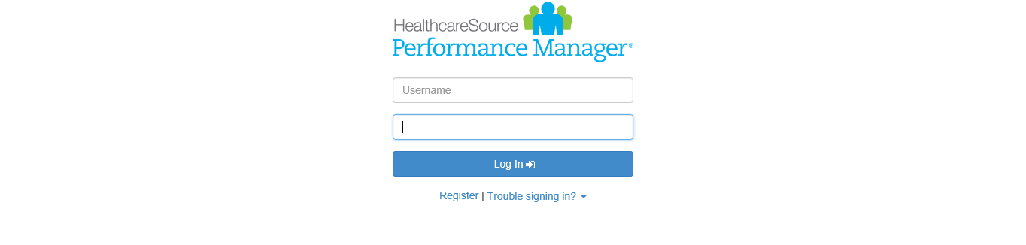

- Fill in your first given name, last name, and Employee ID (HR will furnish).
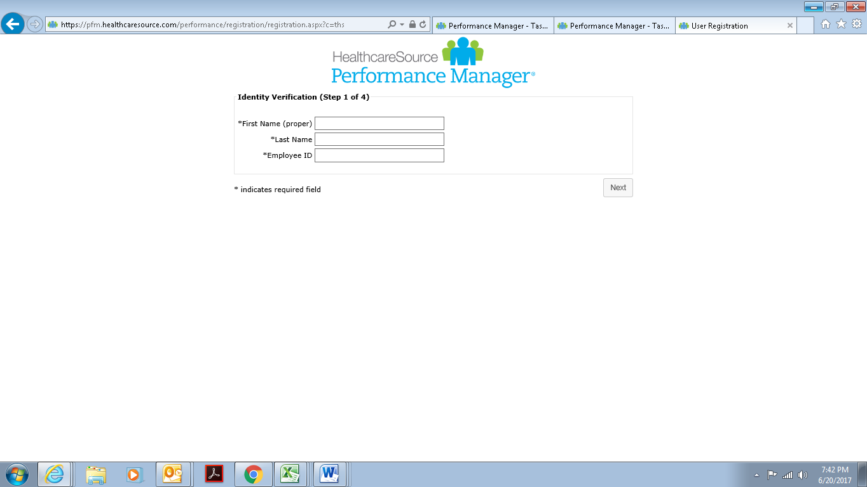

- Enter a new password.

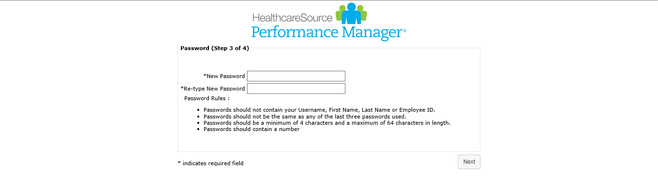

- Enter responses to questions below and/or select new questions from the
drop down.

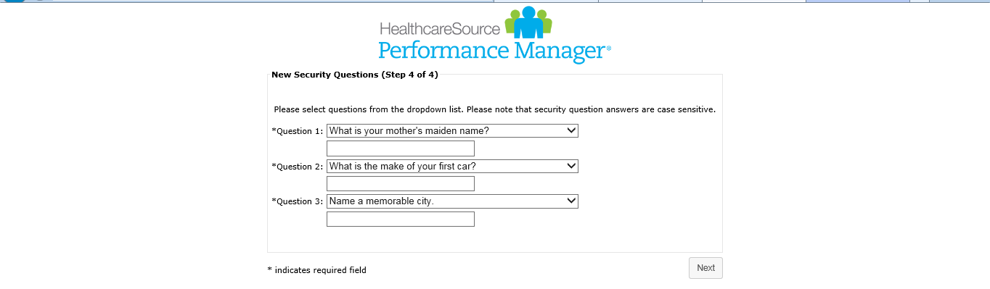

Step 2

Complete the following items in your task bar by hovering cursor over each task:

- Sign job description. Open and scroll to the bottom and select SIGN.
- Sign all Met Life Documents. Open each document and SIGN at the bottom.
- Open initial competency self-assessment and select your experience level with each skill (see example on bottom of page 2 and 3).

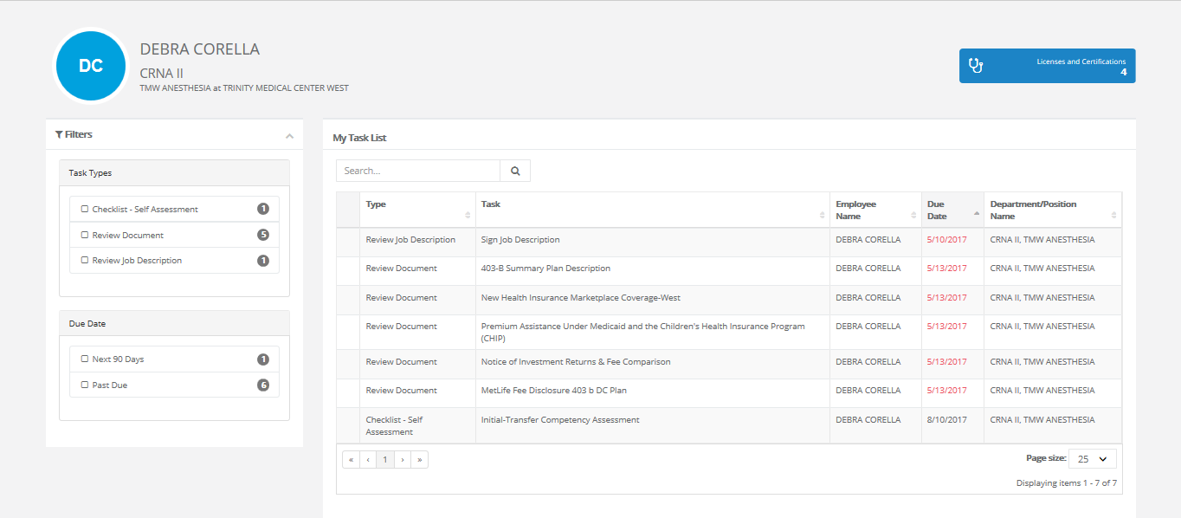

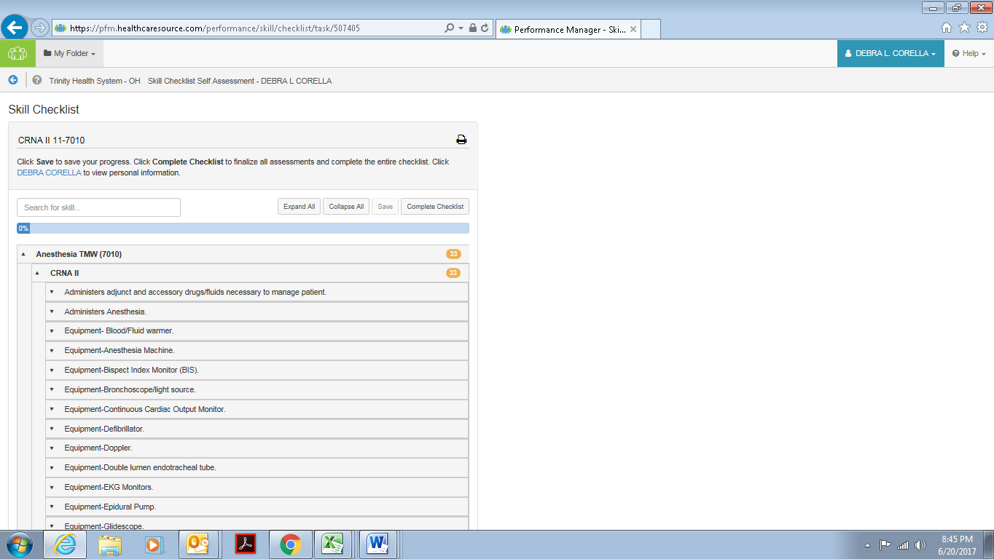
- Expand Initial Competency Self-Assessment
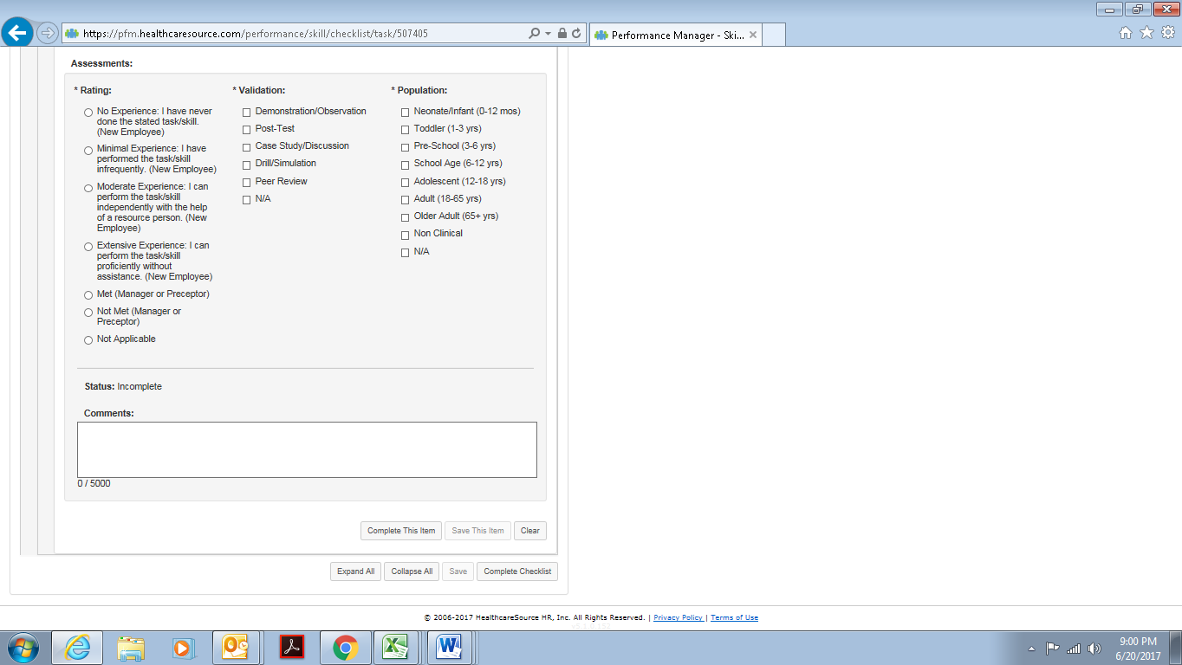
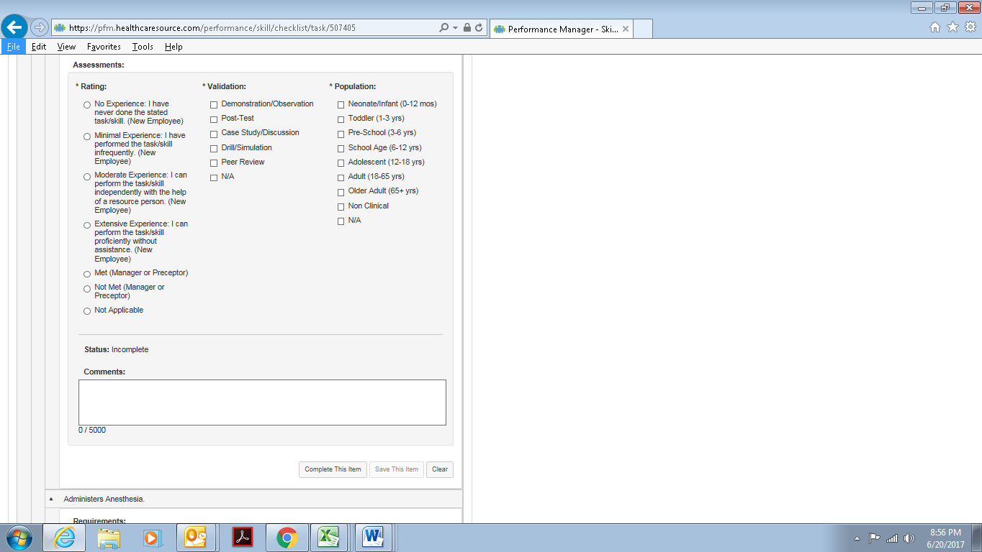
- Select your rating (level of experience only). Mark NA for both Validation and Population. Select Complete this item.
Checklists may range from 1 to multiple pages depending on position. After completing each skill select Complete Checklist.

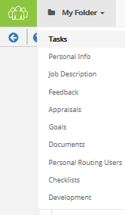
Performance Manager Account

My Folder
Your account has files in My Folder: Tasks, Personal Info, Job Description,
Feedback, Appraisals, Goals, Documents, Checklists, Personal Routing Users
(Managers Only) and Development.

Task Bar
Tasks may include licensure reminder (if you are a licensed person), a performance appraisal (initial or ongoing), coaching, corrective, or positive feedback, department orientation record (new employees only), RN Competency Checklist (new RNs only), and goals.

Personal Info
Includes name, address, position code, position name, department code, department name, facility name, manager name, hire date, position date, employee number.

Job Description
Contains copy(s) of job descriptions.

Feedback
Contains copies of positive (co-worker, patient, other), coaching (behavior or skill needing improvement and/or a new skill), and/or corrective (performance not met). For coaching and corrective feedback, an action plan is completed.

Appraisals
Houses copies of initial and ongoing appraisals, department orientation record (new or transfer), Initial RN Checklist.

Goals
This feature is optional and may or may not be used by your manager. Copies of goal documentation housed here.

Documents
Documents may be uploaded by submitting to Human Resources. Examples may be certificates for continuing education or a special certification.

Checklists
Competency checklists are completed for each employee both initially and each year thereafter by a preceptor or manager.

Development
Area for development plans.

If you need information about your account or forget your password, you can reach out for assistance to the Performance Manager Administrators:

- Cindy Russo, HR Administrative Secretary, West Campus, ext. 8094
- Kathie Pasquarella, Director, Education & Training, ext. 8380

